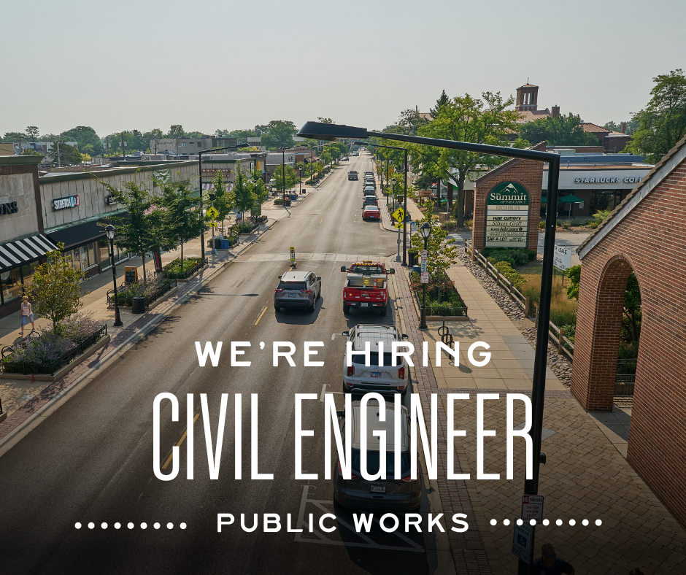

Come and be a part of our Amazing Team!
CIVIL ENGINEER
Starting salary $70,097+ (DOQ)
Do you enjoy helping people, planning large scale projects and coordinating to ensure long term success?
If so, this could be the job for you!
Come and be a part of this great team at the City of Park Ridge!
Please visit our website and job description for more information.

Apply today!

